How do you clone a living organism?

Go on this website: http://learn.genetics.utah.edu/content/tech/cloning/clickandclone/
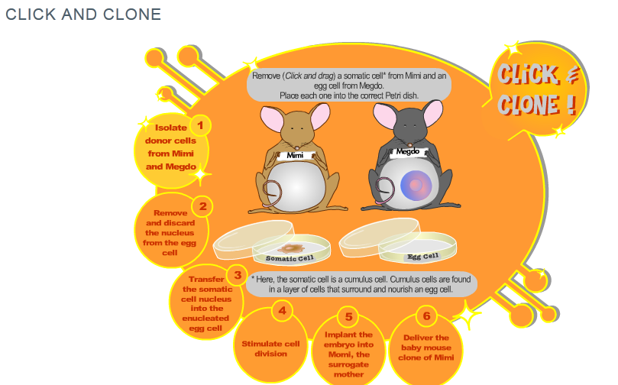
- Click on Mimi to start the experiment. List below the tools you will use:
…………………………………………………………………………………………………………………………………………………………………………………………………………………………………………………………………………………………………………………………………………………………………………………………………………………………………………………………………………………………………………

- Proceed to the first step. Where do the cells you harvested come from?
………………………………………………………………………………………………………………………………………………………………………………………………………………………………………………………………………………………………………………………………………………………………………………

- Proceed to the second step. What do you do with the egg cell form the black mouse?
……………………………………………………………………………………………………………………………………………………………………………………………………………………………………………………

- Proceed to the third step. Explain what you do.
…………………………………………………………………………………………………………………………………………………………………………………………………………………………………………………….…………………………………………………………………………………………………………………………………………………………………………………………………………………………………………………….

- Why do we need to wait after the nucleus transfer?
…………………………………………………………………………………………………………………………………………………………………………………………………………………………………………………….…………………………………………………………………………………………………………………………

- Proceed to the fourth step. What do you obtain at the end of this step?
…………………………………………………………………………………………………………………………………………………………………………………………………………………………………………………….

- Proceed to the fifth step. In which mouse have you implanted the embryo?
…………………………………………………………………………………………………………………………………………………………………………………………………………………………………………………….

- Deliver the baby mouse. What is the color of the mouse? Why?
…………………………………………………………………………………………………………………………………………………………………………………………………………………………………………………….

- Why can we say the baby mouse is a clone of Mimi?
…………………………………………………………………………………………………………………………………………………………………………………………………………………………………………………….…………………………………………………………………………………………………………………………

- Do you know which mammal was first cloned in 1996? If not do a research.
……………………………………………………………………………………………………………………………………………………………………………………………………………………………………………………

- Make a drawing to sum up the experiment.

