THE ISLAND : a movie about human cloning…
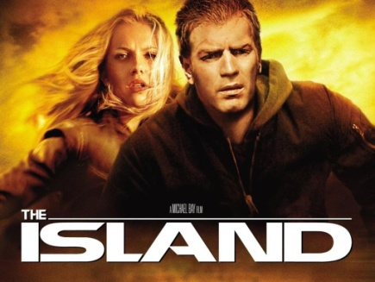
Trailer : http://www.youtube.com/watch?v=vrQZSco77Pg
The Island is a 2005 American science fiction/thriller film directed by Michael Bay, starring Ewan McGregor and Scarlett Johansson. It was released on July 22, 2005, in the United States, and was nominated for three awards, including the Teen Choice Award.
Story:
In the year 2019, Lincoln Six Echo and Jordan Two Delta live with others in an isolated compound*. Their community is governed by a set of strict rules. The residents believe that the outer world has become too contaminated for human life with the exception of one island. Every week a lottery is conducted and the winner gets to leave the compound to live on the island.
Lincoln begins having dreams that include memories that he knows are not from his own experiences. Dr. Merrick, a scientist who runs the compound, is concerned and places probes* in Lincoln's body to monitor his cerebral activity. While secretly visiting an off-limits power facility* in the basement where his friend, technician James McCord, works, Lincoln discovers a live moth* in a ventilation shaft*, leading him to deduce that the outside world is not really contaminated. Lincoln follows the moth to another section, where he discovers that the "lottery" is actually a disguise to remove inhabitants from the compound, where the "winner" is then used for organ harvesting*, surrogate motherhood*, and other purposes for each one's sponsor, who is identical to them in appearance.
Merrick learns that Lincoln has discovered the truth, which forces Lincoln to escape. Meanwhile, Jordan has been selected for the island. Lincoln and Jordan manage to escape the facility, where they emerge in an Arizona desert. He explains the truth to her, and they realize that all the residents are clones of wealthy and/or desperate sponsors, who are kept ignorant of the real world. Merrick hires mercenary Albert Laurent to hunt them down*.
Lincoln and Jordan find McCord in a bar. McCord gives them the name of Lincoln's sponsor in Los Angeles, and helps them to the Yucca railway station, before being killed by the mercenaries. Jordan's sponsor, model Sarah Jordan, is in a coma because of a car accident. Lincoln's sponsor, Tom Lincoln, explains some of the situation, causing Lincoln to realize that he has gained Tom's memories. Tom agrees to help Lincoln and Jordan expose the truth about the organ harvesting, but secretly informs Merrick about the situation by telephone. Merrick sends the mercenaries to their location, but Lincoln tricks* Laurent into killing Tom, allowing him to assume Tom's identity.
Merrick, having realized a cloning defect* was responsible for Lincoln's memories and behavior, decides to eliminate the four newest generations of clones. Lincoln and Jordan, however, plan to liberate their fellow clones. Posing as Tom, Lincoln returns to the compound in order to destroy the holographic projectors that conceal the outside world from the clones. With help from Laurent, who has moral qualms about the clones' treatment, Merrick is killed and the clones are freed, seeing the outside world for the first time. The film fades out with Lincoln and Jordan sailing off in a boat together.

VOCABULARY
compound: enceinte
probes: sondes
facility: équipement, complexe
moth: papillon de nuit
ventilation shaft: conduit d’aération
organ harvesting: prélèvement d’organe
surrogate motherhood: recours à une mere porteuse
to hunt sb/sth down: traquer
to trick: duper
defect: défaut, anomalie

