Human cloning may be soon a reality…

Embryonic stem cells: Advance in medical human cloning
By James Gallagher Health and science reporter,
BBC News
15 May 2013 Last updated at 18:02 GMT

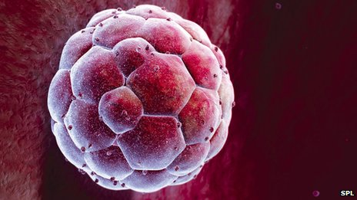
An embryo at the blastocyst stage
Human cloning has been used to produce early embryos, marking a "significant step" for medicine, say US scientists.
The cloned embryos were used as a source of stem cells*, which can make new heart muscle, bone, brain tissue or any other type of cell in the body.
The study, published in the journal Cell, used methods like those that produced Dolly the sheep in the UK.
However, researchers say other sources of stem cells may be easier, cheaper and less controversial.
Opponents say it is unethical to experiment on human embryos and have called for a ban*.
Stem cells are one of the great hopes for medicine. Being able to create new tissue might be able to heal the damage caused by a heart attack or repair a severed spinal cord*.
There are already trials taking place using stem cells taken from donated embryos to restore people's sight*.
However, these donated cells do not match the patient so they would be rejected by the body. Cloning bypasses* this problem.

The technique used - somatic cell nuclear transfer - has been well-known since Dolly the sheep became the first mammal* to be cloned, in 1996.

Skin cells were taken from an adult and the genetic information was placed inside a donor egg which had been stripped of its own DNA. Electricity was used to encourage the egg to develop into an embryo.
However, researchers have struggled to reproduce the feat* in people. The egg does start dividing, but never goes past the 6-12 cell stage (…).
Now a team at the Oregon Health and Science University have developed the embryo to the blastocyst stage - around 150 cells - which is enough to provide a source of embryonic stem cells.

Cloned babies?
Could scientists fully clone a person? It's an interesting question that emerges from this research.
These researchers have certainly developed a cloned embryo further than anyone else.
But producing a five-day-old embryo is a world away from a woman giving birth to the first human clone.
The embryo would need to be implanted as per IVF, but primate research shows that things often go wrong before the clone is born.
Prof Robin Lovell-Badge of the UK National Institute for Medical Research said: "It is an unsafe* procedure in animals and it will similarly be an unsafe procedure in humans. For this reason alone it should not be attempted."
It would also be illegal in some countries, such as the UK, which differentiate between "therapeutic" and "reproductive" cloning.
Source: http://www.bbc.co.uk/news/health-22540374

*stem cells : cellules souches. Une cellule souche est une cellule indifférenciée c'est-à-dire qui n’a pas de spécialité, à l’inverse d’une cellule musculaire par exemple. Une cellule souche peut sous l’effet de différents facteurs se différencier et se diviser pour engendrer de nouvelles cellules spécialisées. C’est un mécanisme de renouvellement au sein de certains tissus dont les cellules se renouvellent souvent comme la peau ou le sang.
*a ban : une interdiction
*the spinal cord : la moelle épinière
*the sight : la vue
*to bypass : contourner
* a mammal : un mammifère
*unsafe : dangereux, peu sûr
*the feat : l’exploit, la prouesse

Questions :

- Nature, source and focus of the document?

- For which purpose human cloned embryos may be used widely in the future?

- What is the problem when you recreate a tissue for a patient with stem cells from donated embryos?

- How does cloning bypass this problem?

- Why haven’t scientists tried to recreate a tissue with a cloned embryo before?

- What is the feat carried out by a team at the Oregon Health and Science University?

- Are we closed to obtain a cloned baby? Why?

- In your opinion which questions will this breakthrough raise?

