Tâche finale theme “Human cloning”
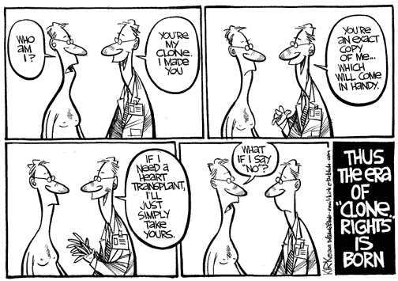
http://www.lasalle.edu/~price/cartoon%20page.htm
Welcome in 2040! Human cloning is now possible and allowed. Imagine a story in which a character is cloned for a special purpose. Shoot a video around 5 minutes about this story in groups of 4.
You must use the vocabulary learned in English class and Biology class. You will be evaluated on the quality of your English and your expression but also on the overall quality of your work.
There must be some valuable scientific content but also suspense and it must be scary !!!

